PROGRAM:

<html>

<head>

<style>

p {

color: red;

text-align: center;

}

</style>

</head>

<body>

<p>Hello World!</p>

<p>These paragraphs are styled with CSS.</p>

</body>

</html>

OUTPUT:

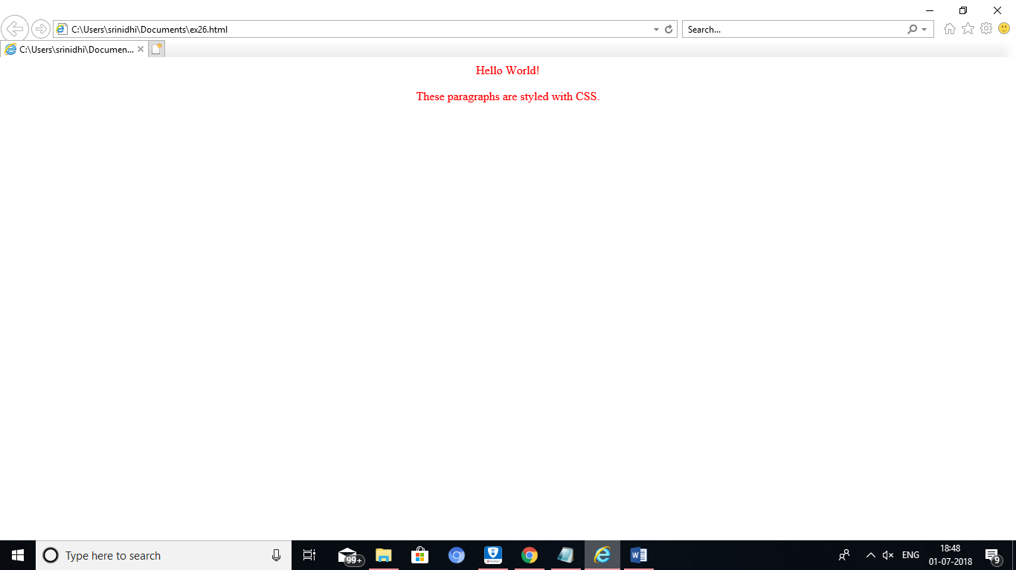

RESULT:

PROGRAM:

<html>

<head>

<link rel="stylesheet" type="text/css" href="mystyle.css">

</head>

<body>

<body bgcolor="#FFF000">

<h1>This is a heading</h1>

<p>This is a paragraph.</p>

</body>

</html>

OUTPUT:

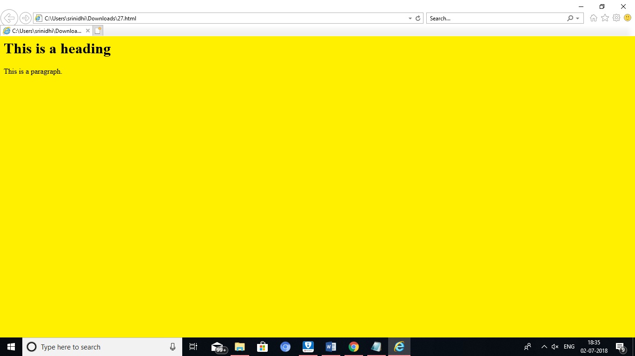

RESULT:

PROGRAM:

<html>

<body>

<h1 style="color:blue;margin-left:30px;">web programming</h1>

</body>

</html>

OUTPUT:

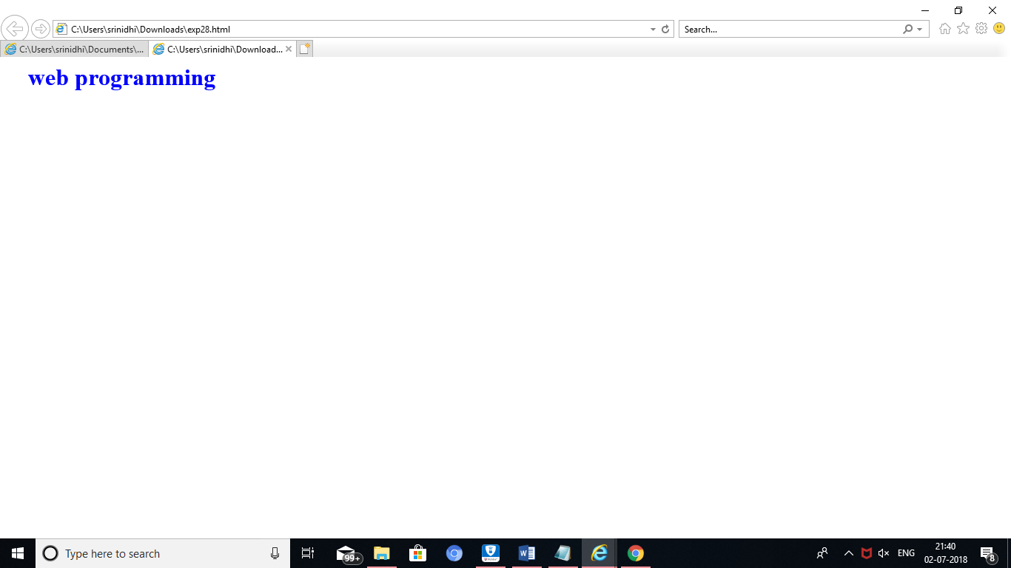

RESULT:

PROGRAM:

(for link)

<html>

<head>

<style>

a:link {

background-color: yellow;

}

</style>

</head>

<body>

<a href="https://www.w3schools.com">W3Sschools</a>

<a href="http://www.wikipedia.org">Wikipedia</a>

</body>

</html>

OUTPUT:

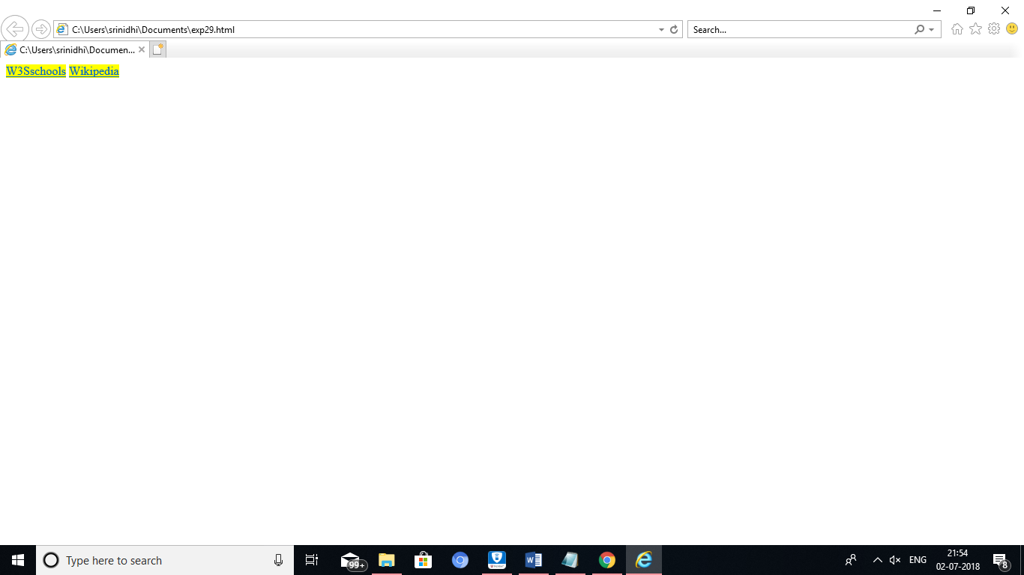

(for visited)

<html>

<head>

<style>

a:visited {

color: pink;

}

</style>

</head>

<body>

<a href="https://www.w3schools.com">W3Schools Home</a><br>

<a href="https://www.w3schools.com/html/">W3Schools HTML Tutorial</a><br>

<a href="https://www.w3schools.com/css/">W3Schools CSS Tutorial</a>

</body>

</html>

OUTPUT:

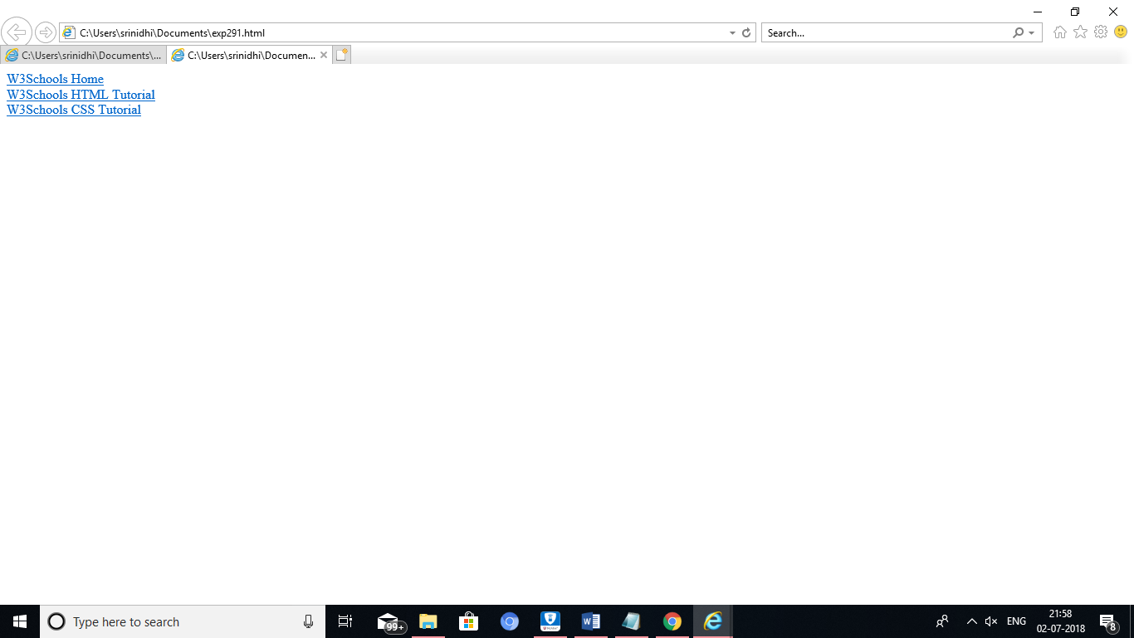

(for hover)

<html>

<head>

<style>

a:hover {

background-color: yellow;

}

</style>

</head>

<body>

<a href="https://www.w3schools.com">w3schools.com</a>

<a href="https://www.wikipedia.org">wikipedia.org</a>

</body>

</html>

OUTPUT:

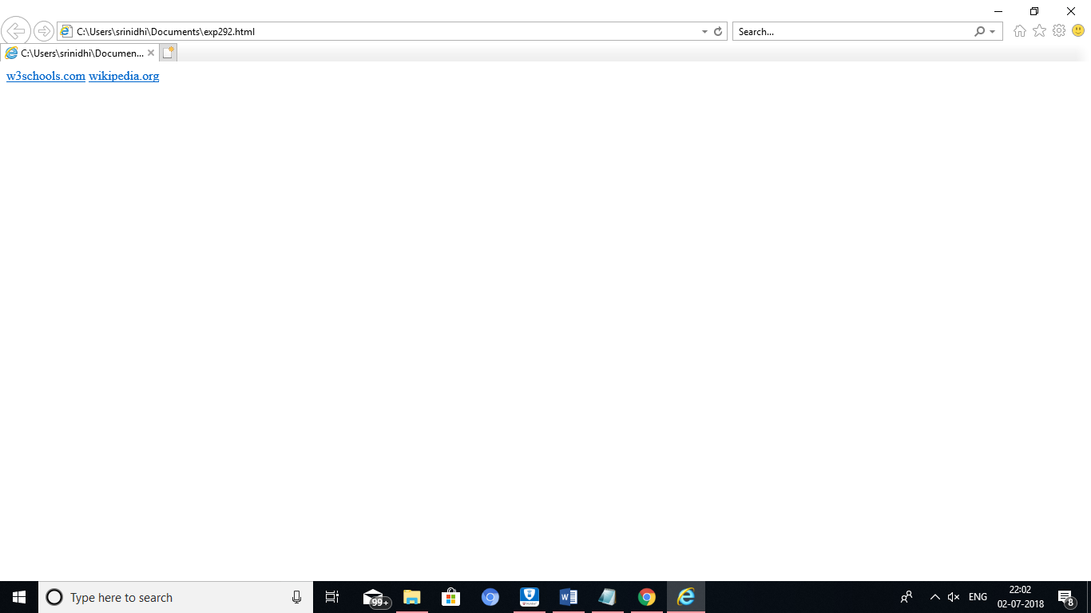

(for active)

<html>

<head>

<style>

a:active {

background-color: yellow;

}

</style>

</head>

<body>

<a href="https://www.w3schools.com">w3schools.com</a>

<a href="http://www.wikipedia.org">wikipedia.org</a>

</body>

</html>

OUTPUT:

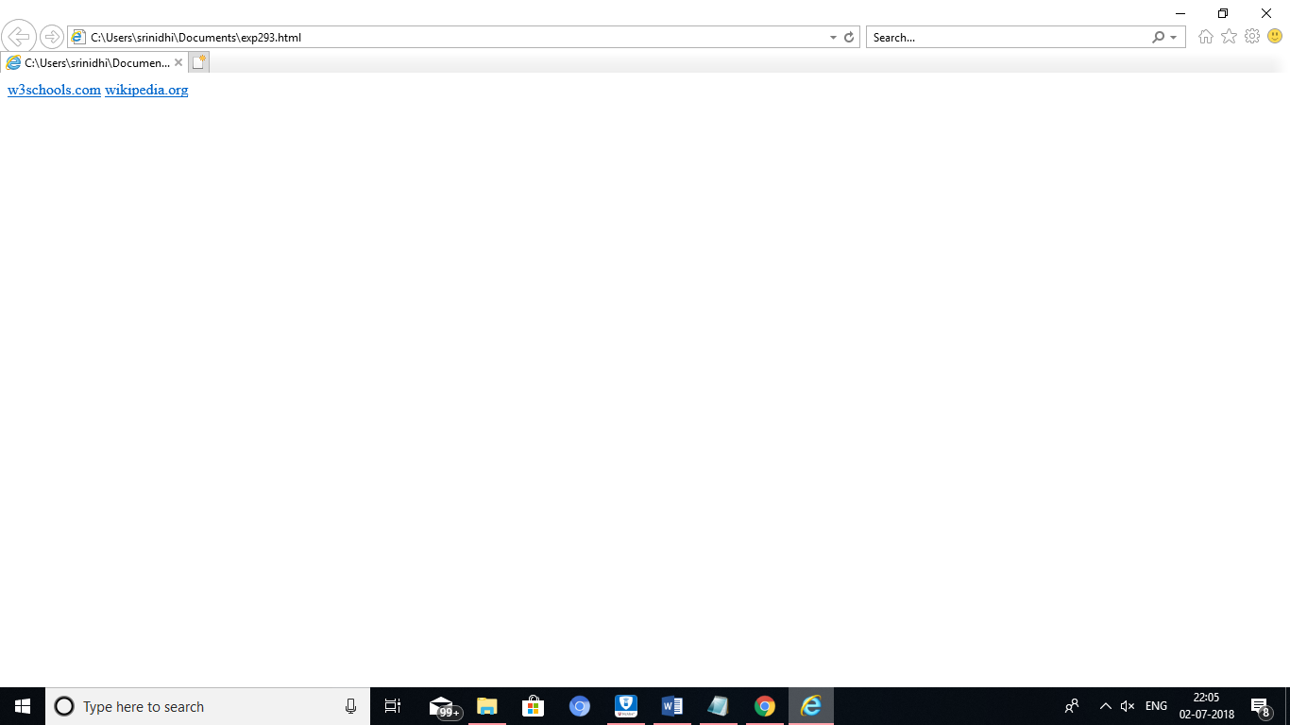

OVERALL OUTPUT:

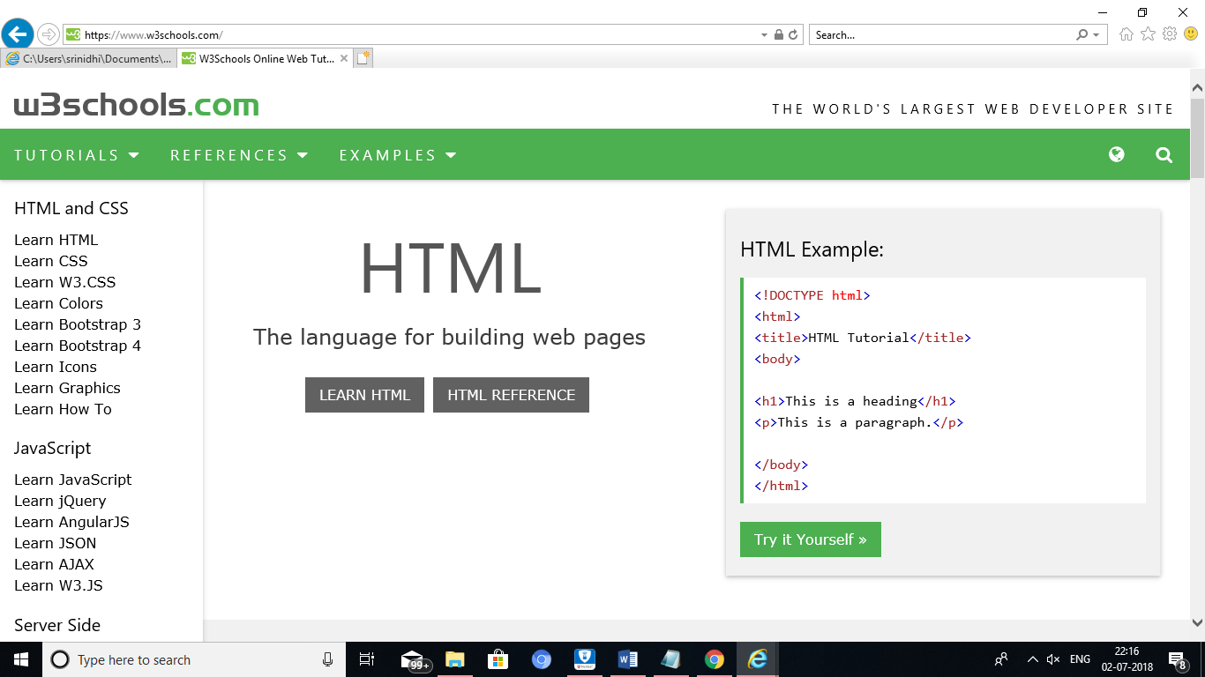

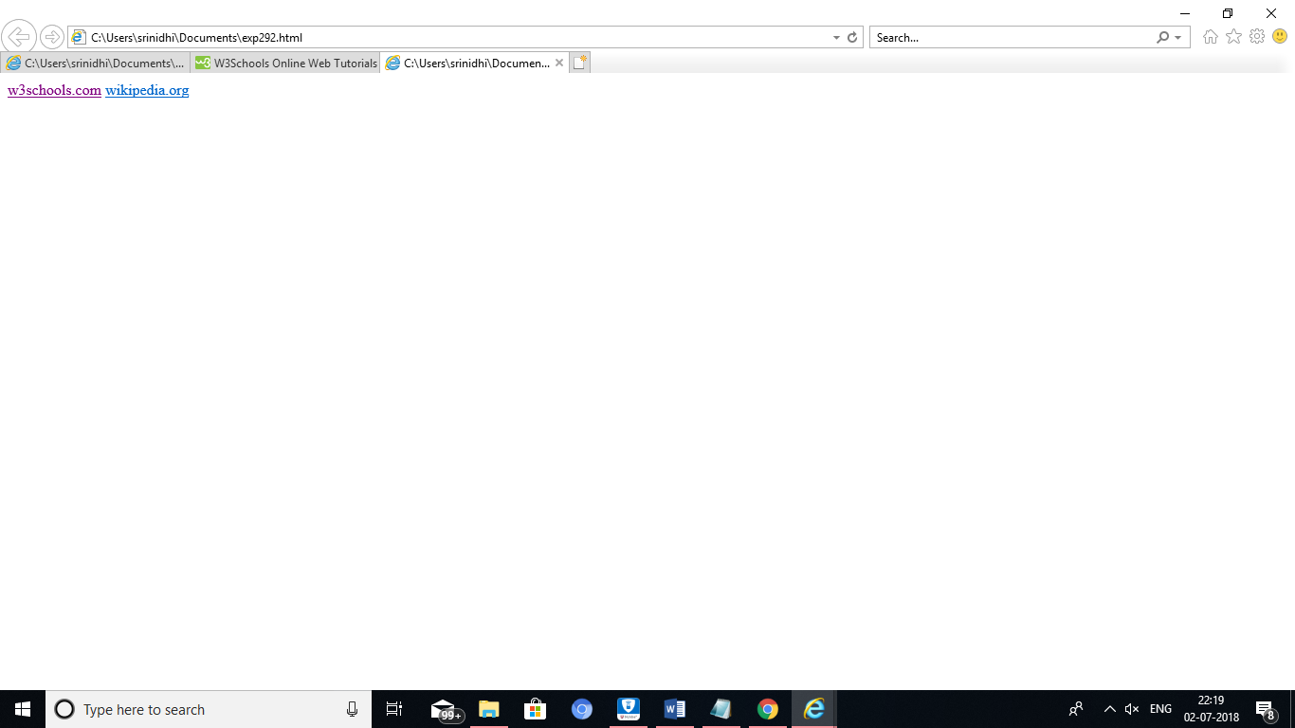

RESULT:

PROGRAM:

<html>

<head>

<style>

body {

background-color: lightblue;

}

</style>

</head>

<body>

<h1>css background </h1>

</body>

</html>

OUTPUT:

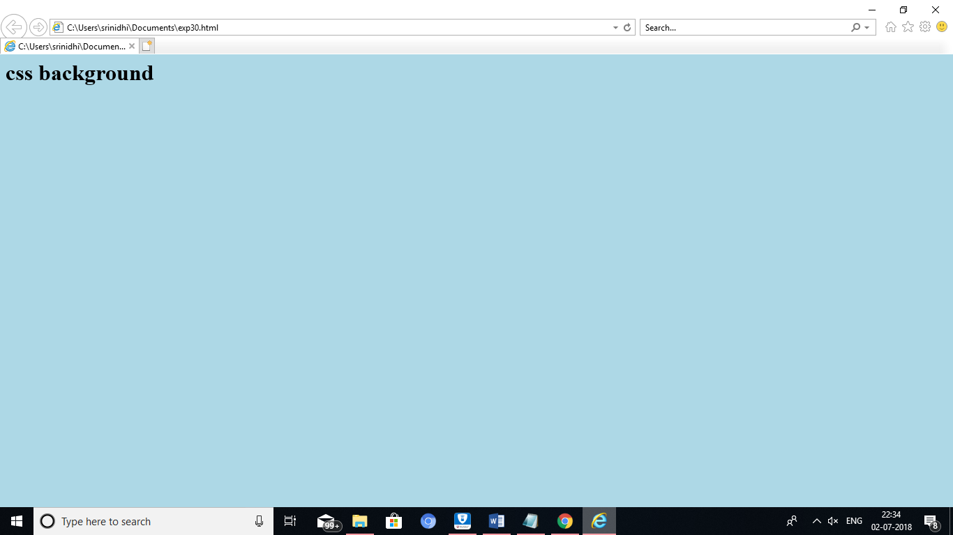

RESULT:

PROGRAM:

<html>

<head>

<style>

p.serif {

font-family: "Times New Roman", Times, serif;

}

p.sansserif {

font-family: Arial, Helvetica, sans-serif;

}

</style>

</head>

<body>

<h1>CSS font-family</h1>

<p class="serif">This is a paragraph, shown in the Times New Roman font.</p>

<p class="sansserif">This is a paragraph, shown in the Arial font.</p>

</body>

</html>

OUTPUT:

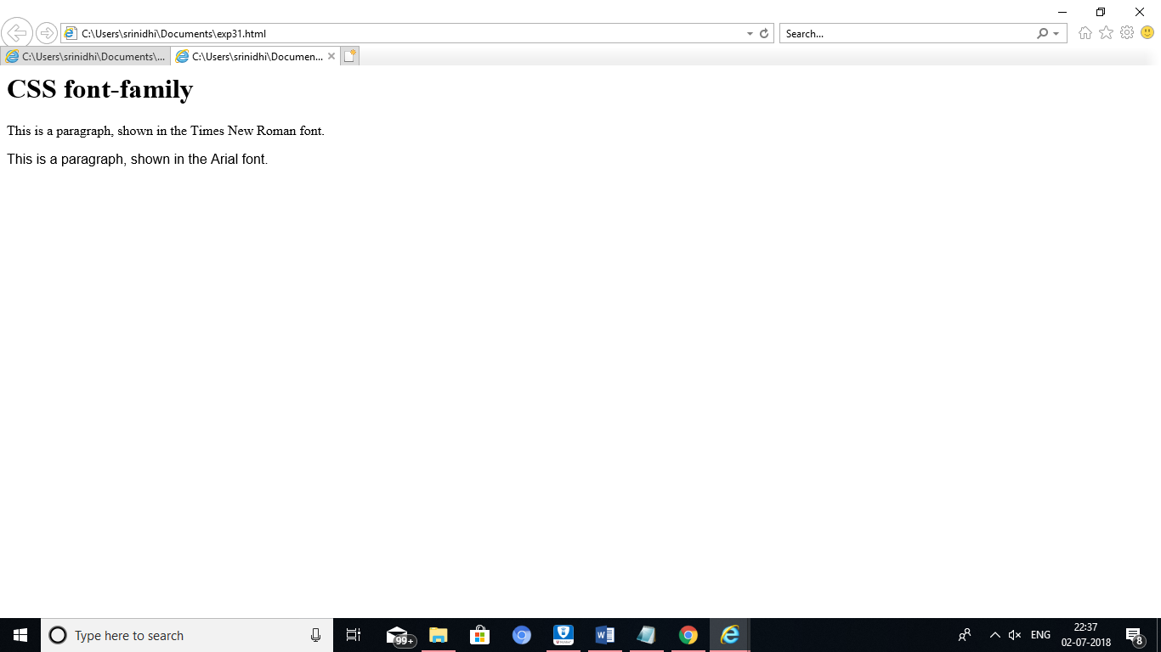

RESULT:

PROGRAM:

<html>

<head>

<style>

div {

border: 1px solid gray;

padding: 8px;

}

h1 {

text-align: center;

text-transform: uppercase;

color: #4CAF50;

}

p {

text-indent: 50px;

text-align: justify;

letter-spacing: 3px;

}

a {

text-decoration: none;

color: #008CBA;

}

</style>

</head>

<body>

<div>

<h1>text formatting</h1>

<p>This text is styled with some of the text formatting properties. The heading uses the text-align, text-transform, and color properties.

The paragraph is indented, aligned, and the space between characters is specified. The underline is removed from this colored

<a target="_blank" href="tryit.asp?filename=trycss_text">"Try it Yourself"</a> link.</p>

</div>

</body>

</html>

OUTPUT:

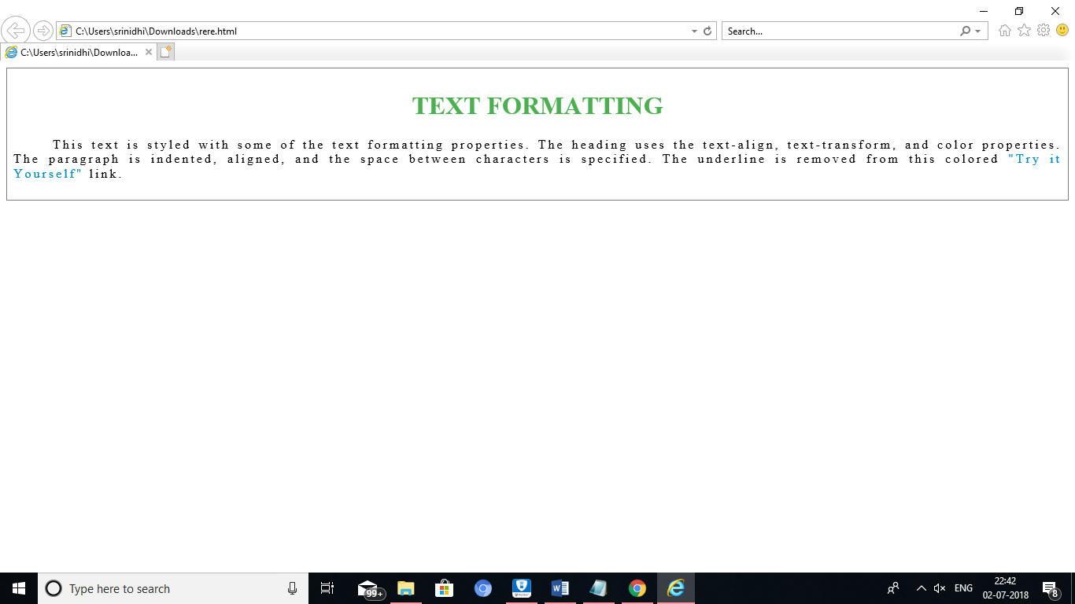

RESULT:

PROGRAM:[36]

<html>

<head>

<style>

ul.a {

list-style-type: circle;

}

ul.b {

list-style-type: square;

}

ol.c {

list-style-type: upper-roman;

}

ol.d {

list-style-type: lower-alpha;

}

</style>

</head>

<body>

<p>Example of unordered lists:</p>

<ul class="a">

<li>Coffee</li>

<li>Tea</li>

<li>Coca Cola</li>

</ul>

<ul class="b">

<li>Coffee</li>

<li>Tea</li>

<li>Coca Cola</li>

</ul>

<p>Example of ordered lists:</p>

<ol class="c">

<li>Coffee</li>

<li>Tea</li>

<li>Coca Cola</li>

</ol>

<ol class="d">

<li>Coffee</li>

<li>Tea</li>

<li>Coca Cola</li>

</ol>

</body>

</html>

OUTPUT:

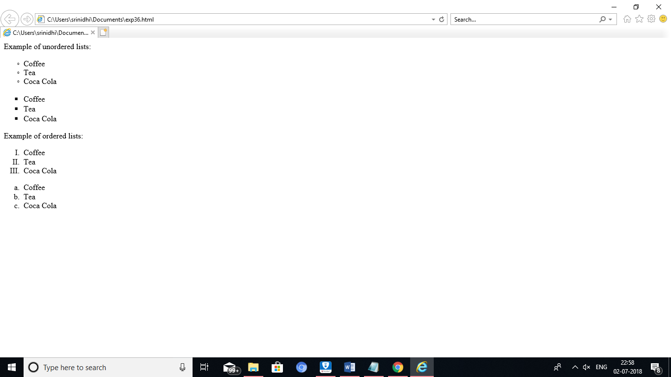

RESULT:

PROGRAM:[35]

<html>

<head>

<style>

p.dotted {border-style: dotted;}

p.dashed {border-style: dashed;}

p.solid {border-style: solid;}

p.double {border-style: double;}

p.groove {border-style: groove;}

p.ridge {border-style: ridge;}

p.inset {border-style: inset;}

p.outset {border-style: outset;}

p.none {border-style: none;}

p.hidden {border-style: hidden;}

p.mix {border-style: dotted dashed solid double;}

</style>

</head>

<body>

<h2>The border-style Property</h2>

<p>This property specifies what kind of border to display:</p>

<p class="dotted">A dotted border.</p>

<p class="dashed">A dashed border.</p>

<p class="solid">A solid border.</p>

<p class="double">A double border.</p>

<p class="groove">A groove border.</p>

<p class="ridge">A ridge border.</p>

<p class="inset">An inset border.</p>

<p class="outset">An outset border.</p>

<p class="none">No border.</p>

<p class="hidden">A hidden border.</p>

<p class="mix">A mixed border.</p>

</body>

</html>

OUTPUT:

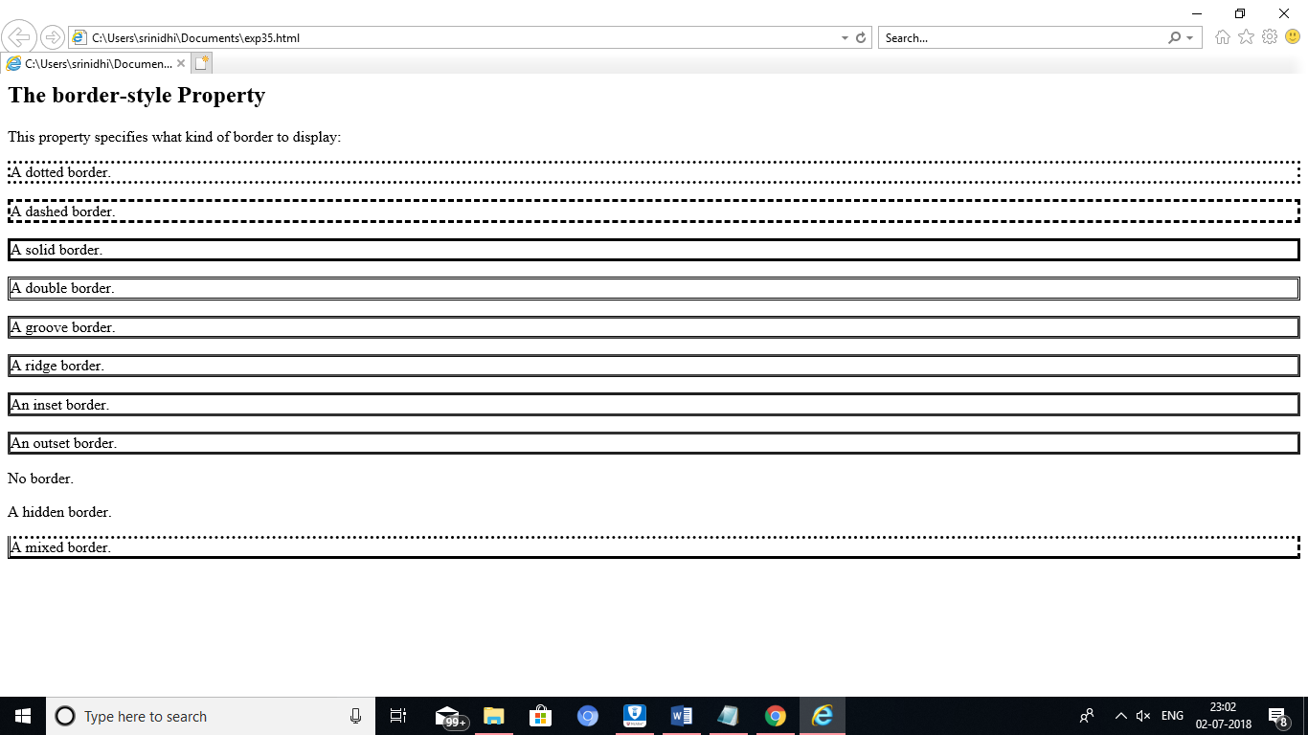

RESULT:

PROGRAM:[39]

<html>

<body>

<h2>HTML Forms</h2>

<form action="/action_page.php">

First name:<br>

<input type="text" name="firstname" value="Mickey">

<br>

Last name:<br>

<input type="text" name="lastname" value="Mouse">

<br><br>

</form>

</body>

</html>

OUTPUT:

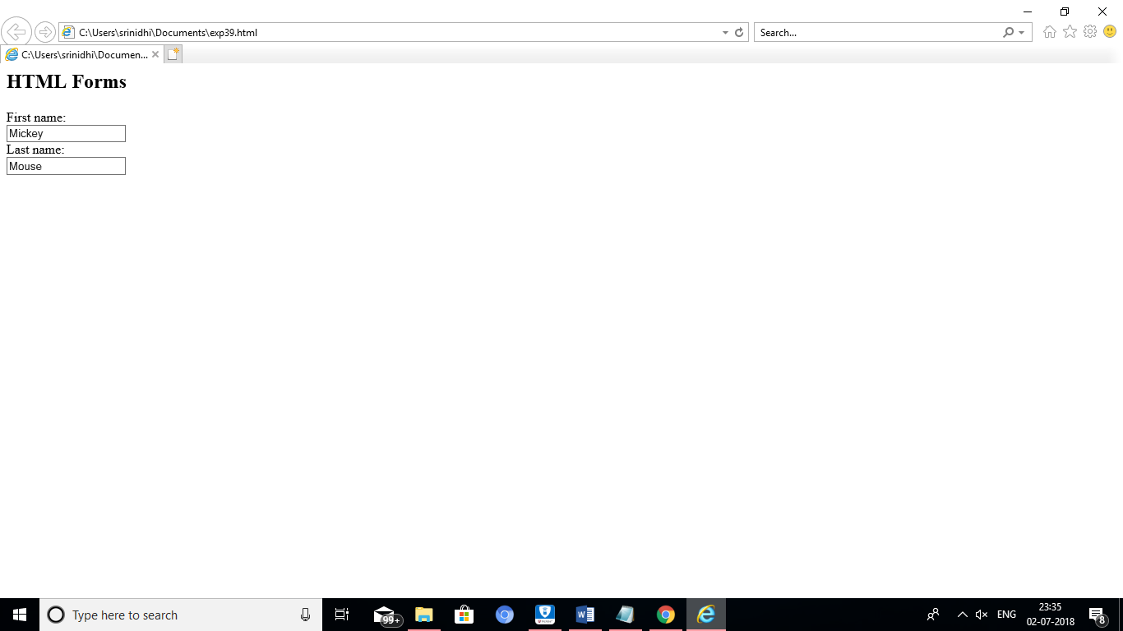

RESULT:

PROGRAM:[40]

<html>

<body>

<h2>Text field</h2>

<p>The <strong>input type="text"</strong> defines a one-line text input field:</p>

<form action="/action_page.php">

First name:<br>

<input type="text" name="firstname">

<br>

Last name:<br>

<input type="text" name="lastname">

<br><br>

</form>

</body>

</html>

OUTPUT:

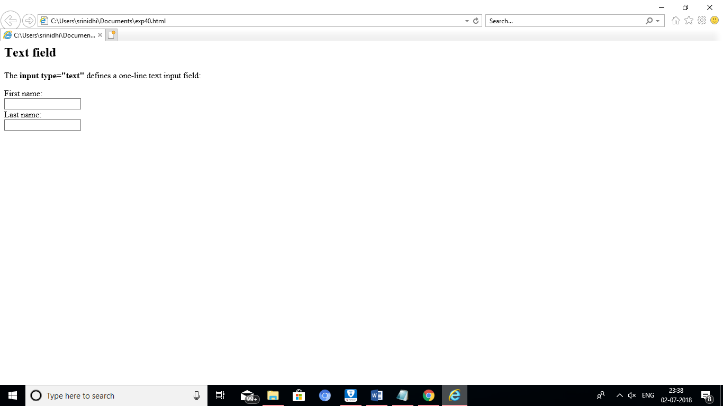

RESULT:

PROGRAM:[41]

<html>

<body>

<h2>Text field</h2>

<p>The <strong>input type="text"</strong> defines a one-line text input field:</p>

<form action="/action_page.php">

First name:<br>

<input type="text" name="firstname">

<br>

Last name:<br>

<input type="text" name="lastname">

<br><br>

</form>

</body>

</html>

OUTPUT:

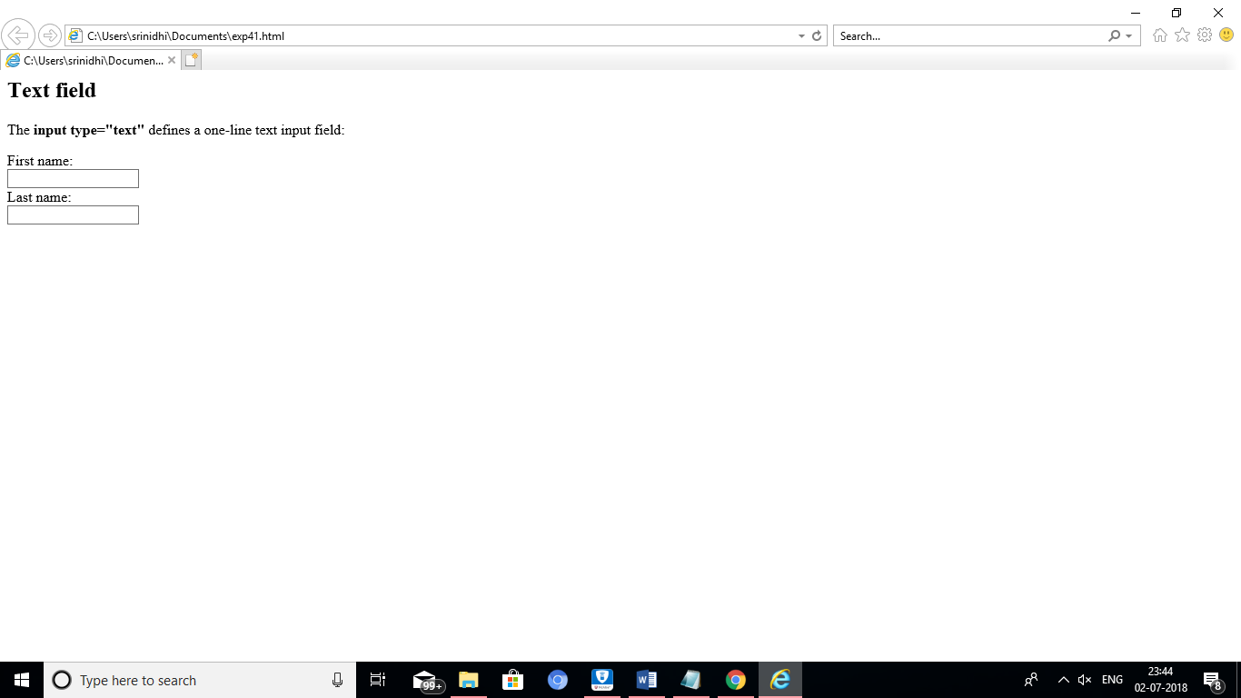

RESULT:

PROGRAM:42

<html>

<body>

<h2>Password field</h2>

<p>The <strong>input type="password"</strong> defines a password field:</p>

<form action="">

User name:<br>

<input type="text" name="userid">

<br>

User password:<br>

<input type="password" name="psw">

</form>

<p>The characters in a password field are masked (shown as asterisks or circles).</p>

</body>

</html>

OUTPUT:

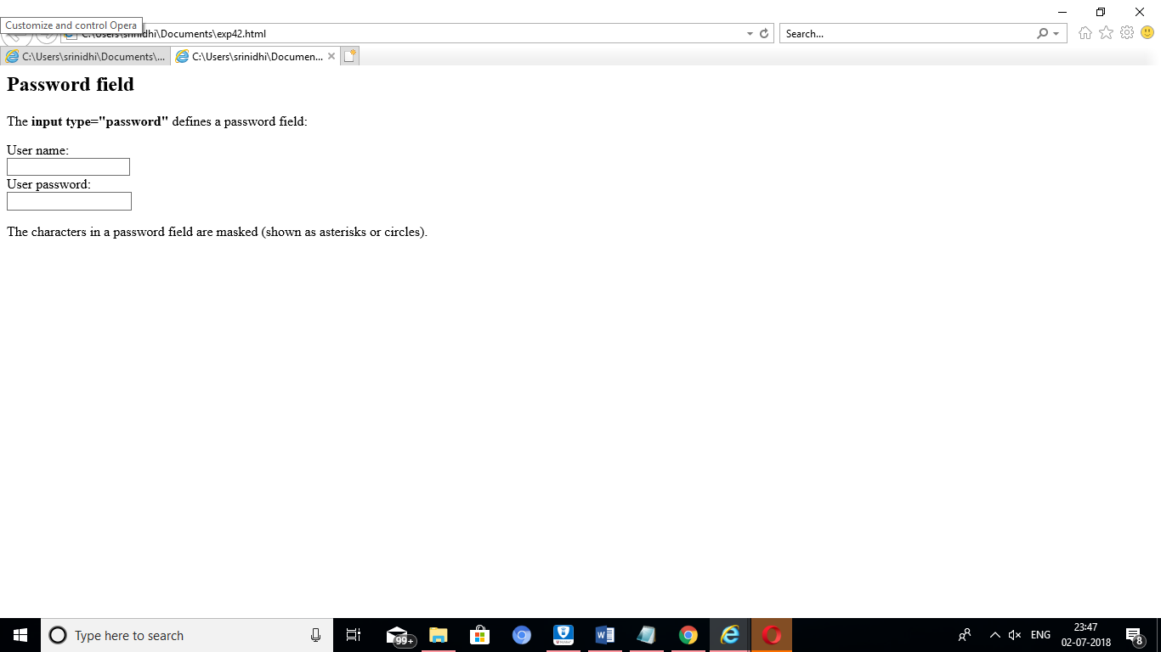

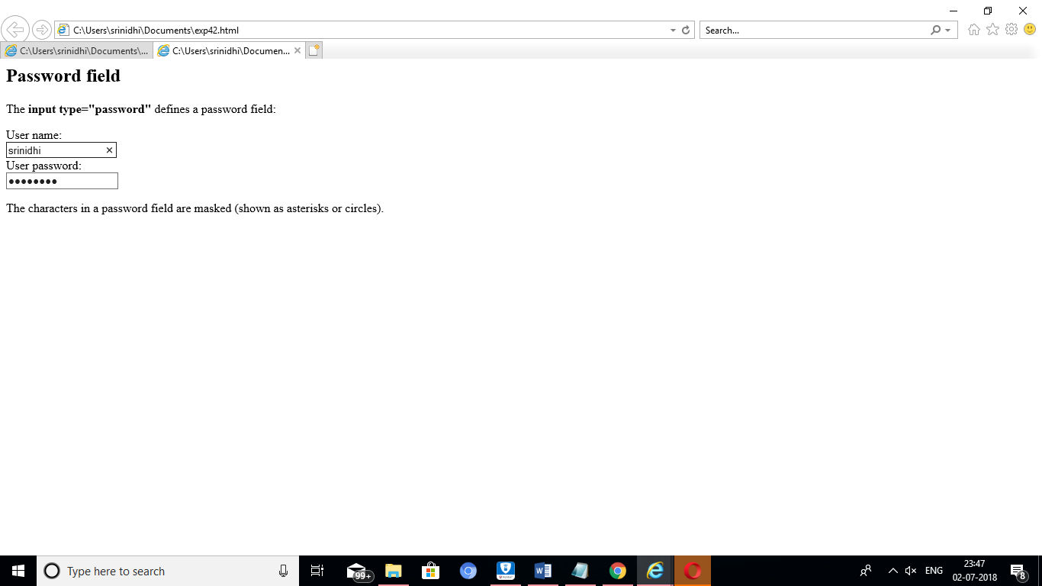

RESULT:

PROGRAM:43

<html>

<body>

<h2>Reset Button</h2>

<p>The <strong>input type="reset"</strong> defines a reset button that will reset all form values to their default values:</p>

<form action="/action_page.php">

First name:<br>

<input type="text" name="firstname" value="Mickey">

<br>

Last name:<br>

<input type="text" name="lastname" value="Mouse">

<br><br>

<input type="submit" value="Submit">

<input type="reset">

</form>

<p>If you change the input values and then click the "Reset" button, the form-data will be reset to the default values.</p>

</body>

</html>

OUTPUT:

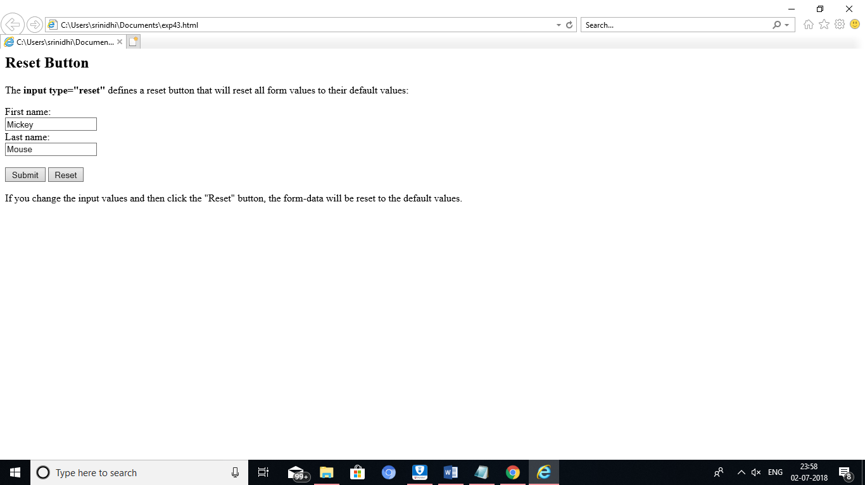

RESULT:

PROGRAM:44

<html>

<body>

<h2>Submit Button</h2>

<p>The <strong>input type="submit"</strong> defines a button for submitting form data to a form-handler:</p>

<form action="/action_page.php">

First name:<br>

<input type="text" name="firstname" value="virat">

<br>

Last name:<br>

<input type="text" name="lastname" value="kohli">

<br><br>

<input type="submit" value="Submit">

</form>

<p>If you click "Submit", the form-data will be sent to a page called "/action_page.php".</p>

</body>

</html>

OUTPUT:

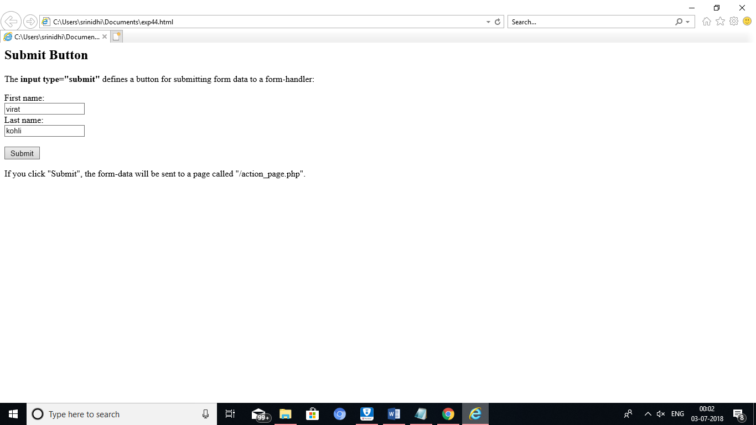

RESULT:

PROGRAM:45

<html>

<body>

<h2>Checkboxes</h2>

<p>The <strong>input type="checkbox"</strong> defines a checkbox:</p>

<form action="/action_page.php">

<input type="checkbox" name="vehicle1" value="Bike">I have a bike

<br>

<input type="checkbox" name="vehicle2" value="Car">I have a car

<br><br>

<input type="submit">

</form>

</body>

</html>

OUTPUT:

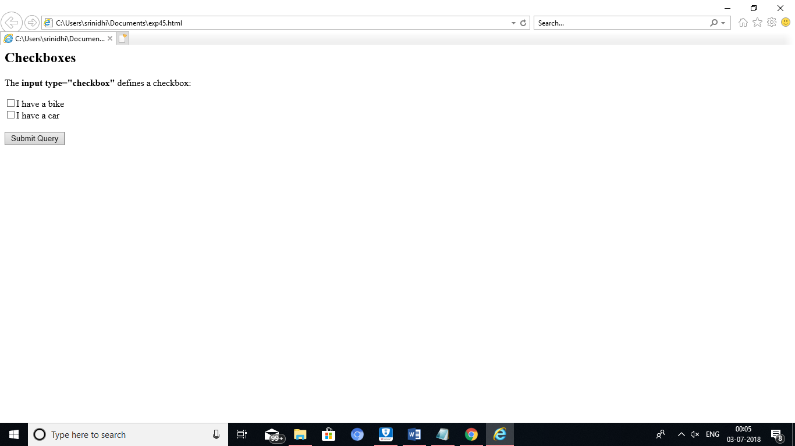

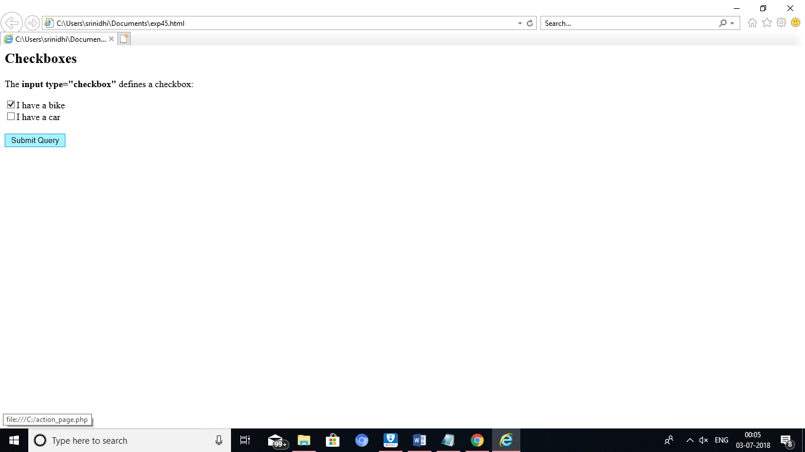

RESULT:

PROGRAM:46

<html>

<body>

<h2>Radio Buttons</h2>

<p>The <strong>input type="radio"</strong> defines a radio button:</p>

<form action="/action_page.php">

<input type="radio" name="gender" value="male" checked> Male<br>

<input type="radio" name="gender" value="female"> Female<br>

<input type="radio" name="gender" value="other"> Other<br><br>

<input type="submit">

</form>

</body>

</html>

OUTPUT:

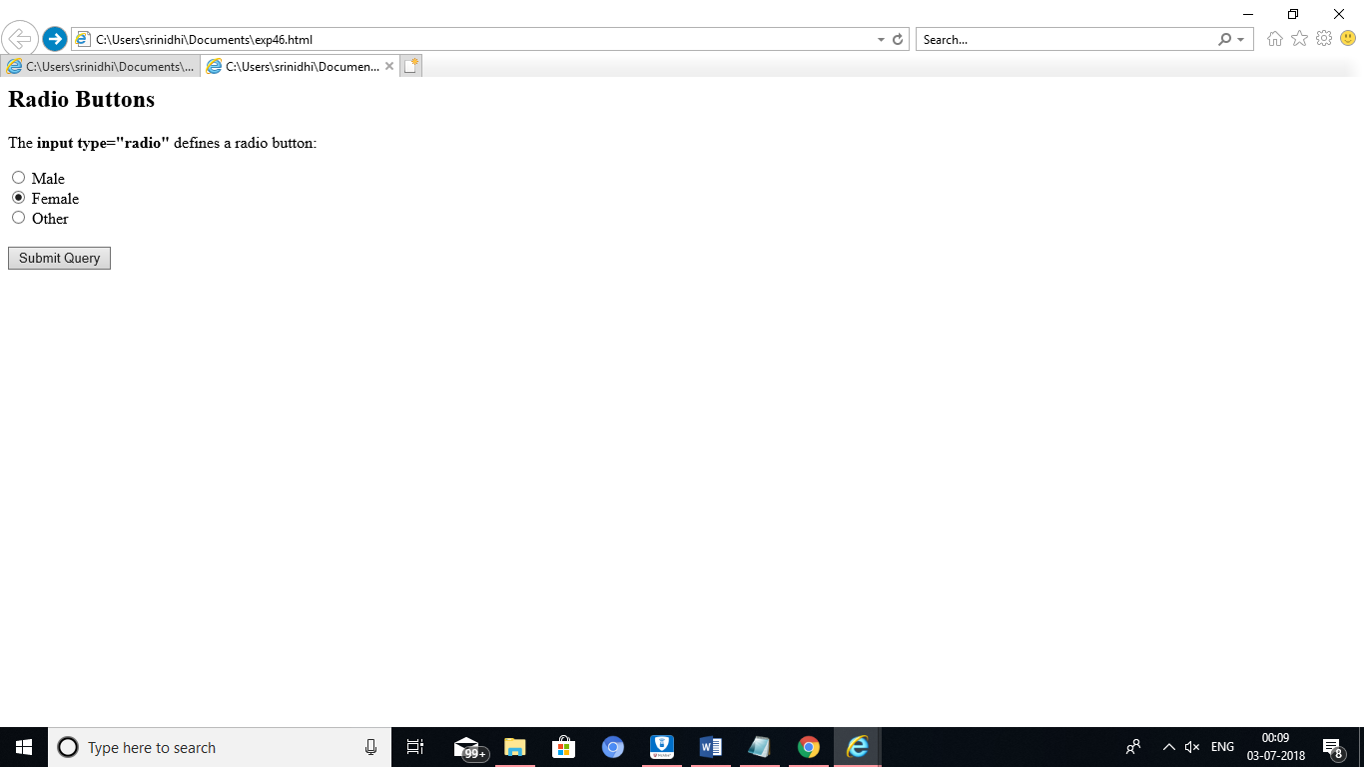

RESULT:

PROGRAM:47

<html>

<body>

<h2>The select Element</h2>

<p>The select element defines a drop-down list:</p>

<form action="/action_page.php">

<select name="cars">

<option value="volvo">Volvo</option>

<option value="saab">Saab</option>

<option value="fiat">Fiat</option>

<option value="audi">Audi</option>

</select>

<br><br>

<input type="submit">

</form>

</body>

</html>

OUTPUT:

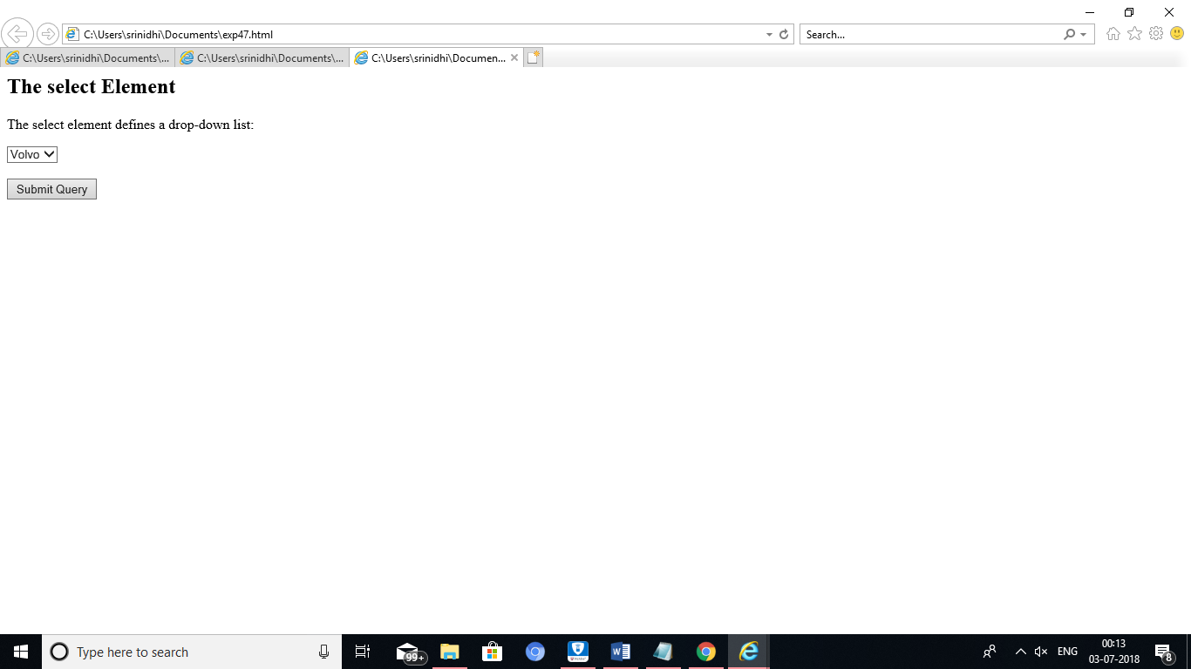

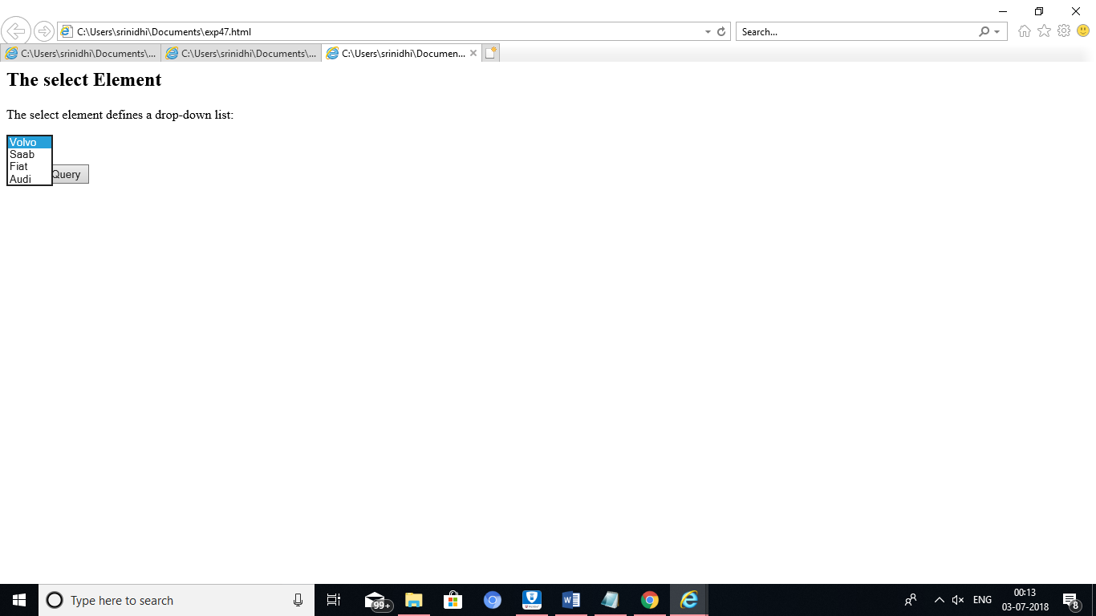

RESULT:

PROGRAM:48

<html>

<body>

<h1>Define a hidden input field:</h1>

<form action="/action_page.php">

First name: <input type="text" name="fname"><br>

<input type="hidden" id="custId" name="custId" value="3487">

<input type="submit" value="Submit">

</form>

<p>Notice that the hidden input field is not shown to the user, but the data is sent when the form is submitted.</p>

</body>

</html>

OUTPUT:

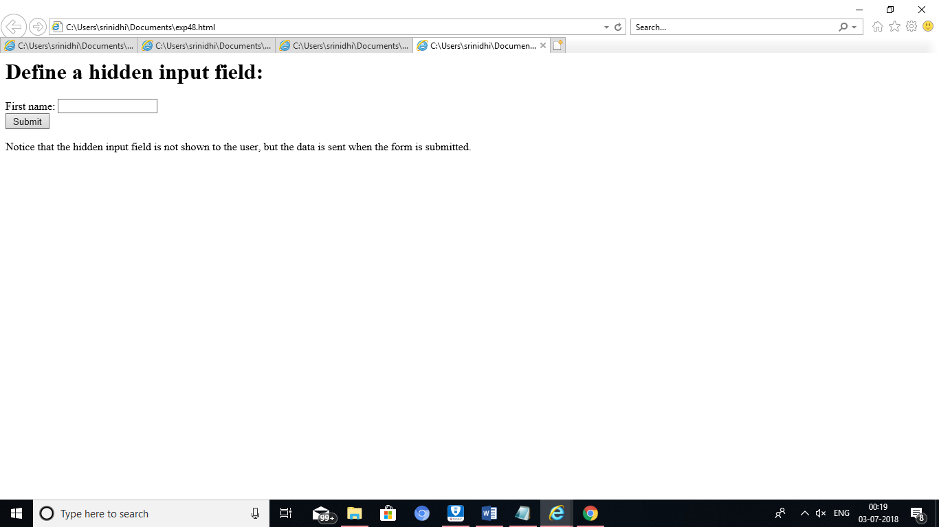

RESULT:

PROGRAM:50

<html>

<body>

<h2>Textarea</h2>

<p>The textarea element defines a multi-line input field.</p>

<form action="/action_page.php">

<textarea name="message" rows="10" cols="30">The cat was playing in the garden.</textarea>

<br>

<input type="submit">

</form>

</body>

</html>

OUTPUT:’

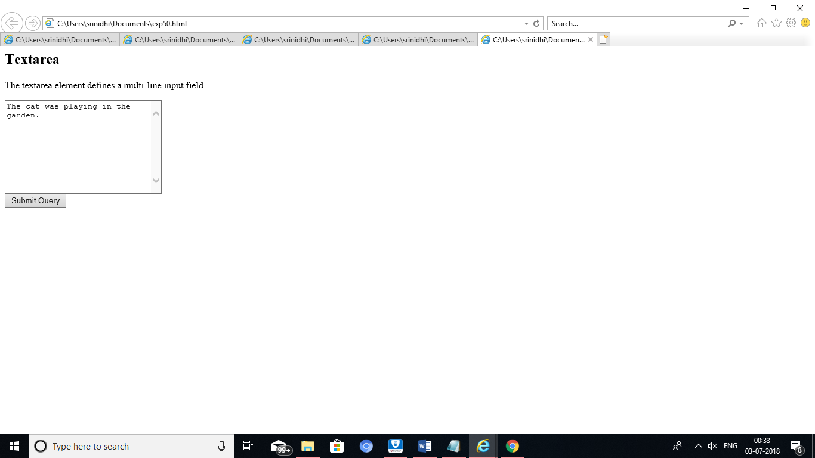

RESULT: